APHFIC annual meeting and screening of Iris Chang: the Rape of Nanking on May 18
As part of Asia Heritage month, APHAFIC hosted a screening of the new film about Iris Chang on May 18, 2008,3:00-5:00 p.m. at the UltraStar Cinema in Mission Valley, 7510 Hazard Center Drive in San Diego. Approximately 370 people attended the movie screening including 60 + students from Point Loma High, Torrey Pines, Grossmont College, SDSU, UCSD and City College. Dan Hom, the SDAFF President, welcomed everyone to the movie followed by the opening remarks of Nancy Lo, who gave the reasons of hosting the movie. She indicated that many people in SD had met Iris in person as she was a frequent visitor to San Diego between 1998-2004 for lectures, book tours for the Rape of Nanking and Chinese in America, speaking engagments at Torrey Pines High School in1998, the 1999 Chinese conference at USD, the Global Alliance 6th biennial conference in 2002 and the APHAFIC annual meeting on April 25, 2004. Nancy Lo thanked all the co-sponsors (see below) and presented a certificate of Appreciation to Mr. Dannis Avery for the significant contribution to the making of the movie from the Avery-Tsui Foundation. Drs. Shai-Jin and Ying-Ying Chang, Iris Chang's parents, answered questions during QA session after the movie. One Chinese lady from Nanking acknowledged John Rabe’s diary obtained by Iris Chang during her research about the Nanking Massacre which recorded her grandfather’s effort to help civilians in the safety zoon. Her grandfather got the recognition and his body was removed from a graveyard in a rural area to the memorial park in Yu-hwa Tai near Nanking.
After the film, the 6th APHAFIC Annual Meeting was held at the Jasmine Seafood Restaurant in Kearny Mesa,6:30 p.m. - 9:30 p.m. Nancy Lo delivered the annual report (for details, please see APHAFIC.org). Drs. Shau-Jin and Ying-Ying Chang, Iris Chang's parents, spoke on "Iris Chang and her writing of the Rape of Nanking" and "Iris Chang and our continuous efforts in promoting the awareness of The Rape of Nanking" respectively.

Dr. Shau-jin Chang, gave the background of Iris Chang from her childhood, that motivated her writing of the book: the Rape of Nanking: Iris first heard of the Rape of Nanking at the family dinner table. Shau-jin’s family was near and Ying-Ying’s family was in Nanking just prior to the occupation of Nanking by Japanese imperial army. After she graduated from high school, Iris entered the University of Illinois at Urbana in 1985 as a Math/Computer Science Major and later on she switched to journalism expecting the objections from her parents. However, to her surprise, her parents did not object. During the spring semester of 1990, Iris registered at the University of Illinois as a non-degree student in the history department. Within a year, Iris got a master degree from Johns Hopkins and wrote her firs book “Thread of Silkworm” about a Chinese rocket scientist Tsien Hsue-shen which was published in 1995. In December 1994, Iris went to an exhibit of WWII in Asia at Cupertino CA. This exhibit included many photos taken at the Rape of Nanking. It reminded her of the story told her by her parents when she was a child. In order to verify the truthfulness of those pictures, she started her own research including her 1995, trip to Taiwan and Nanking, interviewing more than ten Rape of Nanking survivors at Nanking, two at Taiwan, and one at LA. The book was published in 1997. One item learned by Dr. Shau-jin Chang from Iris’ book was the safety zone which was unknown to him. Both her parents provided consultation to Iris during her writing of the book in particular related to the Chinese documentations.

In Dr. Ying-Ying Chang’s speech, she reiterated the life of Iris. Apparently Iris had worked too hard and was overburdened with many responsibilities, and the pressure from outside caused her physical and then mental breakdown. It was heart breaking for Iris’s parents to see their daughter to go so young and so suddenly. For one year and half after her death, the sorrow overwhelmed her mother, who could not face the fact that Iris was gone. In the Spring of 2006, Ying-Ying decided that it was useless to continue moaning the loss and doing nothing. On her birthday March 28, with the assistance of Global Alliance for Preserving the History of WWII in Asia (GA), under which, her parents established Iris Chang Memorial Fund (ICMF) to continue carrying on her unfinished work and dream. The ICMF was used primarily for three projects in the last two years: Essay contest, Support of the High School teacher China Study Tour and movie projects.

Essay Contest
The essay topic of the first ICMF essay contest in 2006 was about the book on The Rape of Nanking and asked how the book affected the reader’s life and thinking. The topic of the second essay contest in 2007 was “The denial and its cost, reflection of Nanking Massacre 70 years ago and beyond” to commemorate the 70th anniversary of the Nanking Massacre. The first prize winner was Mr. Yoshikuni Kaneda , a member of APHAFIC. In his essay, Mr. Kaneda stated that the displaced loyalty to emperor with racism was the main cause of the atrocities Japan committed during the war. He wrote that “One simply cannot rewrite history as one pleases. The denial of wartime atrocities costs too much. It has jeopardized international trust and respect toward Japan.” For both essay contests, around 290 in 2006 and 270 in 2007 essays around the world were received from U.S., Australia, Canada, South Korea, Singapore, Philippines, China including Taiwan and Hong Kong, India, etc. 80% of the essays came from students: high school and college students, but also from people of various occupations

Support High School teacher China Study Tour :

Beside of Essay Contest, ICMF supports high school teachers study tour to China. In each of last two years, around 10 high school teachers from California, New Jersey and Boston went to China to do onsite study of the Japanese atrocities during Japanese invasion. These high school teachers brought their experience and this part of history into their class rooms. This project is another way to supplement the deficiency of current U. S. high schools history curriculum. Note: APHAFIC sponsored Mr. Aaron De Groot, history teacher, San Diego High, to participate the 2007 tour.

Movie projects:

One of Iris’ dreams was to make a movie on the Rape of Nanking based on her book as Iris thought that movie was more powerful than books. Since her passing, two movies on the subject had been made. One is American documentary film “Nanking” and the other is the Canadian movie “Iris Chang:The Rape of Nanking”. Shau-Jin and Ying-Ying served as a consultant to the later movie and participated in the movie. They also assisted both films with their publicities during premieres and screening in theaters. The Nanking was shown in theaters early this year and DVDs are available in bookstores. Distributor is being sought for the second movie. Nevertheless, Iris’ dream has been fulfilled.

In summary, in the past two years, Iris’ parents had held essay competition to raise the awareness of public conscience about Asian Forgotten Holocaust, to support high school teacher study tour and assisted to make movies of The Rape of Nanking.

During their visit to San Diego, Shau-jin and Ying-Ying signed all copies of the Rape of Nanking, which are for sale by APHAFIC.

We thank Robin Low for actively pushing the screening of Iris Chang, and all cosponsors: Gold Circle: Chinese Consolidated benevolent Assn. of San Diego; San Diego Asian film Festival; In Memory of Ying Hing Tsui; Silver Circle: San Diego Chinese Historical Society and Museum; House of China; San Diego Chinese Art Society; U.S.-China Peoples Friendship Assn., San Diego Chinese Assn. American Chinese Culture Education Foundation; Bronze Circle: Yuman & Betty Young, Alex Chuang and Jack Fu

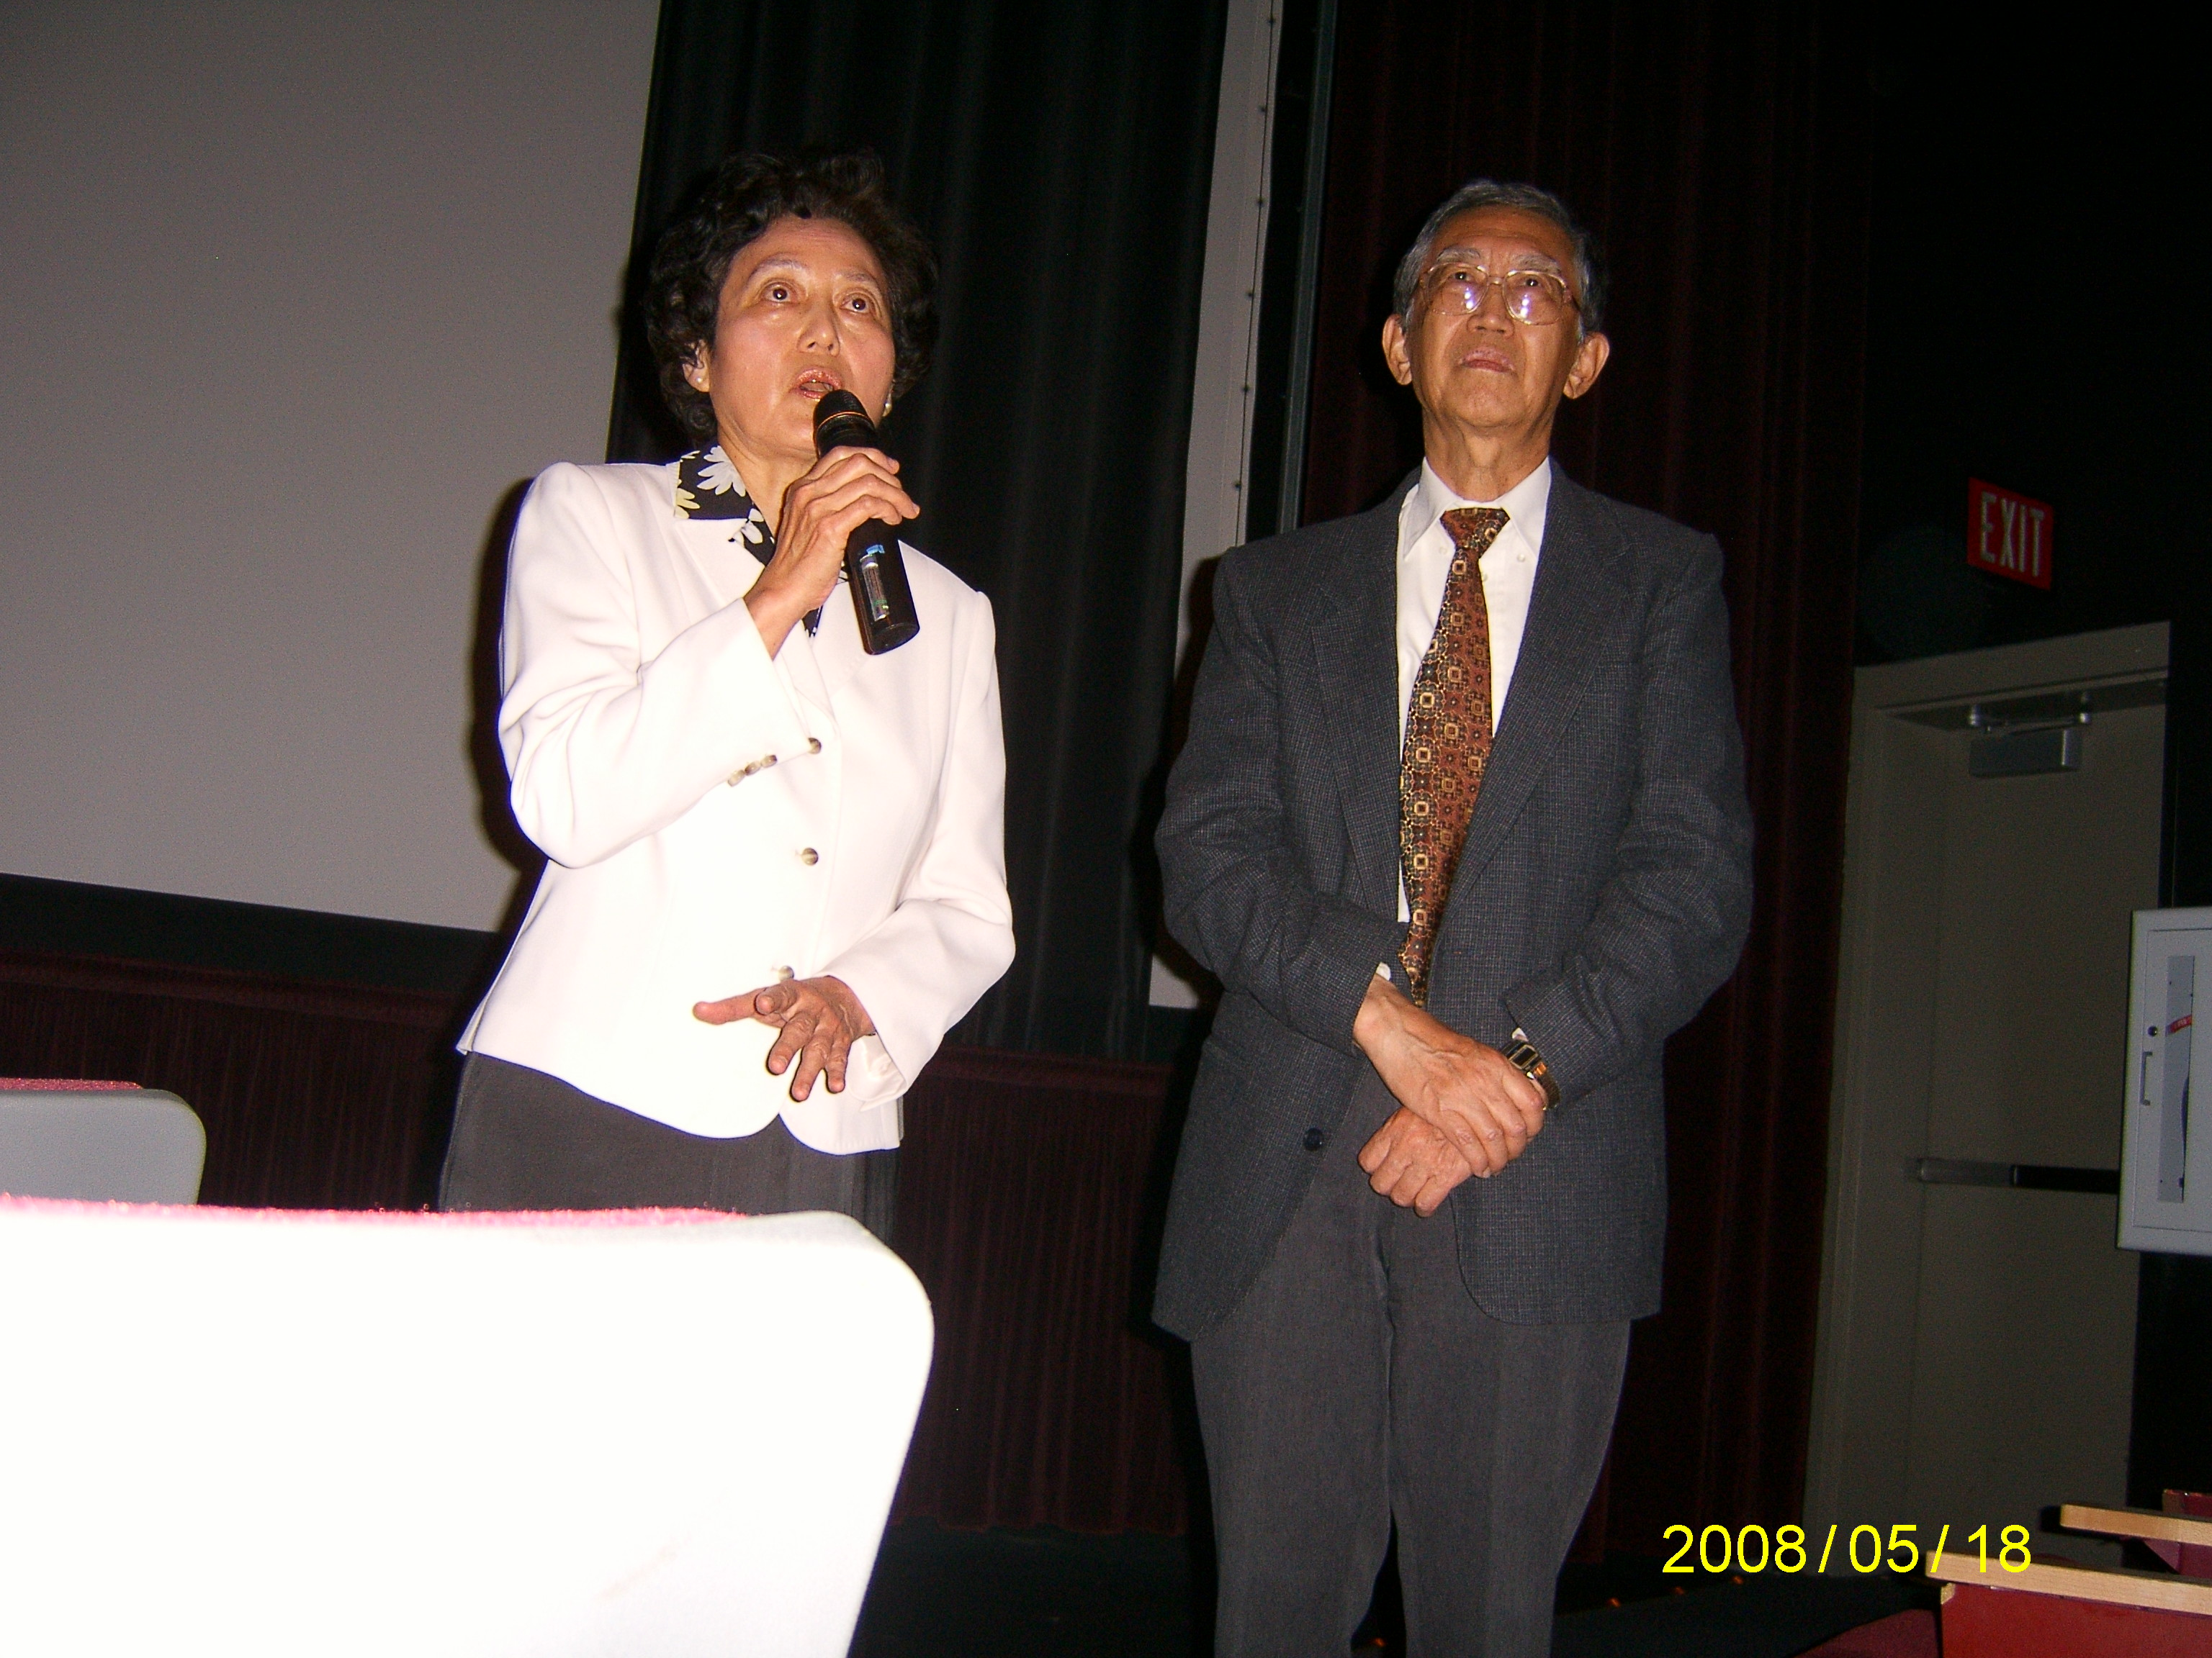
Drs Ying-Ying and Shau-jin Chang answered questions after the movie.

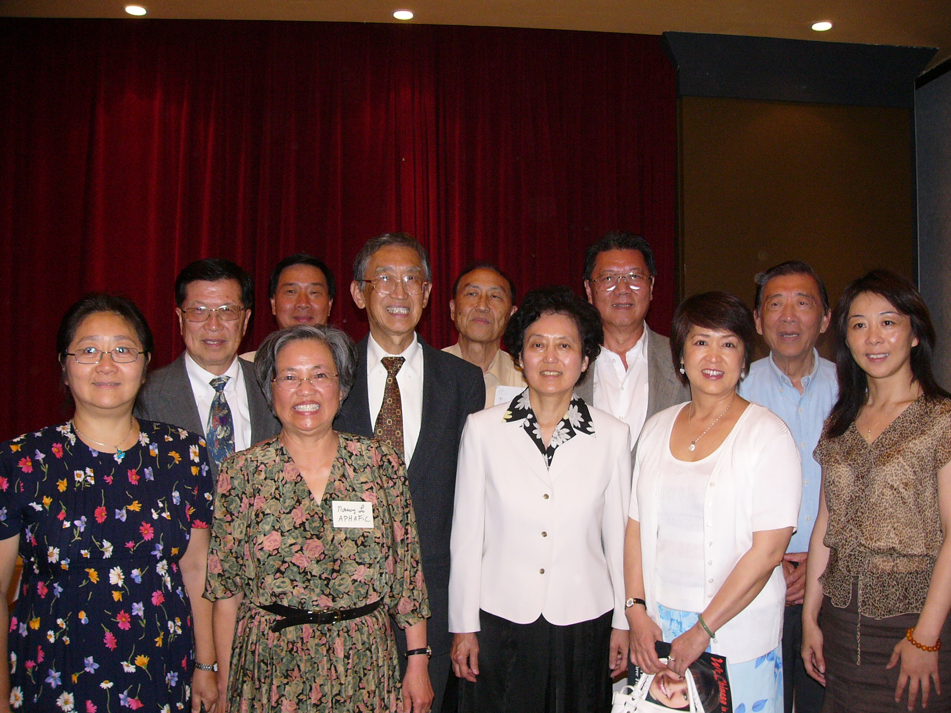
At the annual meeting: May Yan-Lee, David Hu, Robin Low, Nancy Lo, Dr. Shau-jin Chang, Michael Lee, Dr. Ying-Ying Chan, Jack Meng, Lucia Yau, Alex Chuang, and Sha Hongfang, (board members: Daneil Chang, Howard Chang and Lillin Wang are not in the picture)

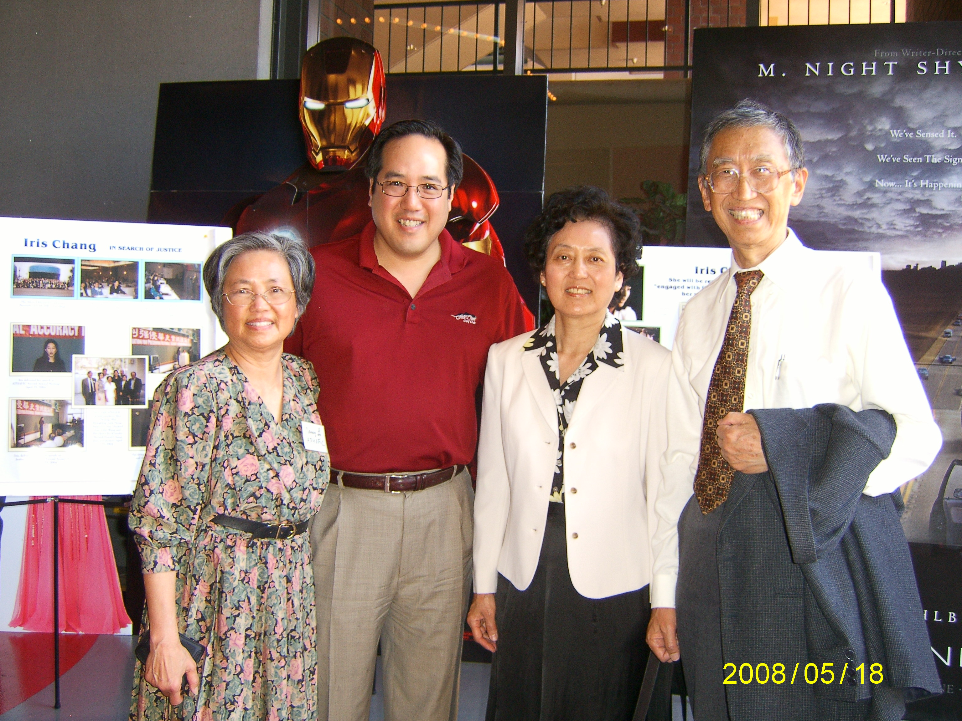
Nancy Lo, Dan Hom, SDAFF President, Drs Ying-Ying and Shau-jin Chang at the theater before the movie.

/tmp/in/input.doc 5/26/2008

