“APHAFIC Members and Donors Appreciation Garden Party” on August 23, 2008 at Fairbanks Park, Fairbanks Ranch, Rancho Santa Fe.

The garden party featured the speech by Dr. Lester Tenney who gave a moving speech on ‘The guilt of the survivor: The Battan Death March’ followed by a question and answer session and book signing.

This Garden Party was held to show our appreciation toward San Diego community organizations and individuals who had support the past activities of the APHAFIC, in particular the screening of the movie of Iris Chang on May 18th 2008: Ed Wang, David Du: Indo-Chinese Association, Lin Xun, Ed Pun, Robin Low, San Diego Asian Film Festival, Chinese Consolidated benevolent Assn. of San Diego (SDCCBA,Bandy Yiu); San Diego Chinese Historical Society and Museum (Alex Chuang); House of China (David Seid); San Diego Chinese Art Society (Jean Tzung); U.S.-China Peoples Friendship Assn. (Alice Hu) , San Diego Chinese Assn (SDCA: Regina Gua, ). American Chinese Culture Education Foundation (Shaoyi He); Jack Meng, Yuman & Betty Young, and Jack Fu. Other associations and individuals that have supported APHAFIC activities in the past are: David Shen, San Diego Northern County Chinese Society, San Diego Chinese Women’s League, San Diego Chinese American Science and Entrepreneur Association, Eparaim Feig, and Jen-shen Lee. Among those presented at the party, Nancy Lo gave representative of each organization (names in the parentheses above) a copy of Iris Chang and the Forgotten Holocaust: Best Essays from Iris Chang Memorial Essay Contest, 2006.

A total of 58 people attended this event including many leaders of San Diego Chinese organizations, APHAFIC members and friends. During the dinner time, Howard Chang presented ‘Southern accent and Northern Enunciation’ (in Chinese), Margaret Zhou played cello , Mack Meng presented Chinese stand-up comedy and Jing Jing Evans played Chinese zither.

Acknowledgements: This event was organized by the APHAFIC event committee: Howard Chang, Wendy Shih, Hongfang Sha, Lillin Wang and Yeqing Chen.
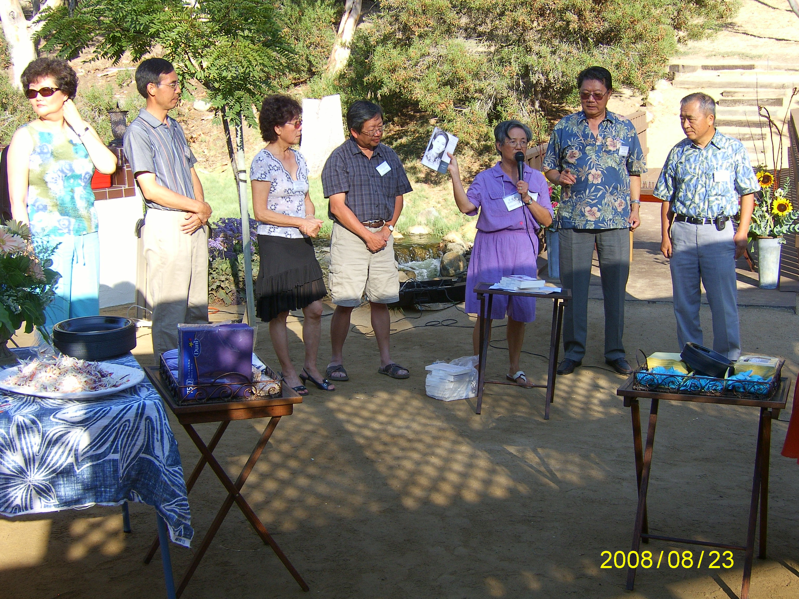
Nancy Lo presented the book of Iris Chang and the Forgotten Holocaust, Best essays from Iris Chang memorial essay contest, 2006 to some organization representatives.

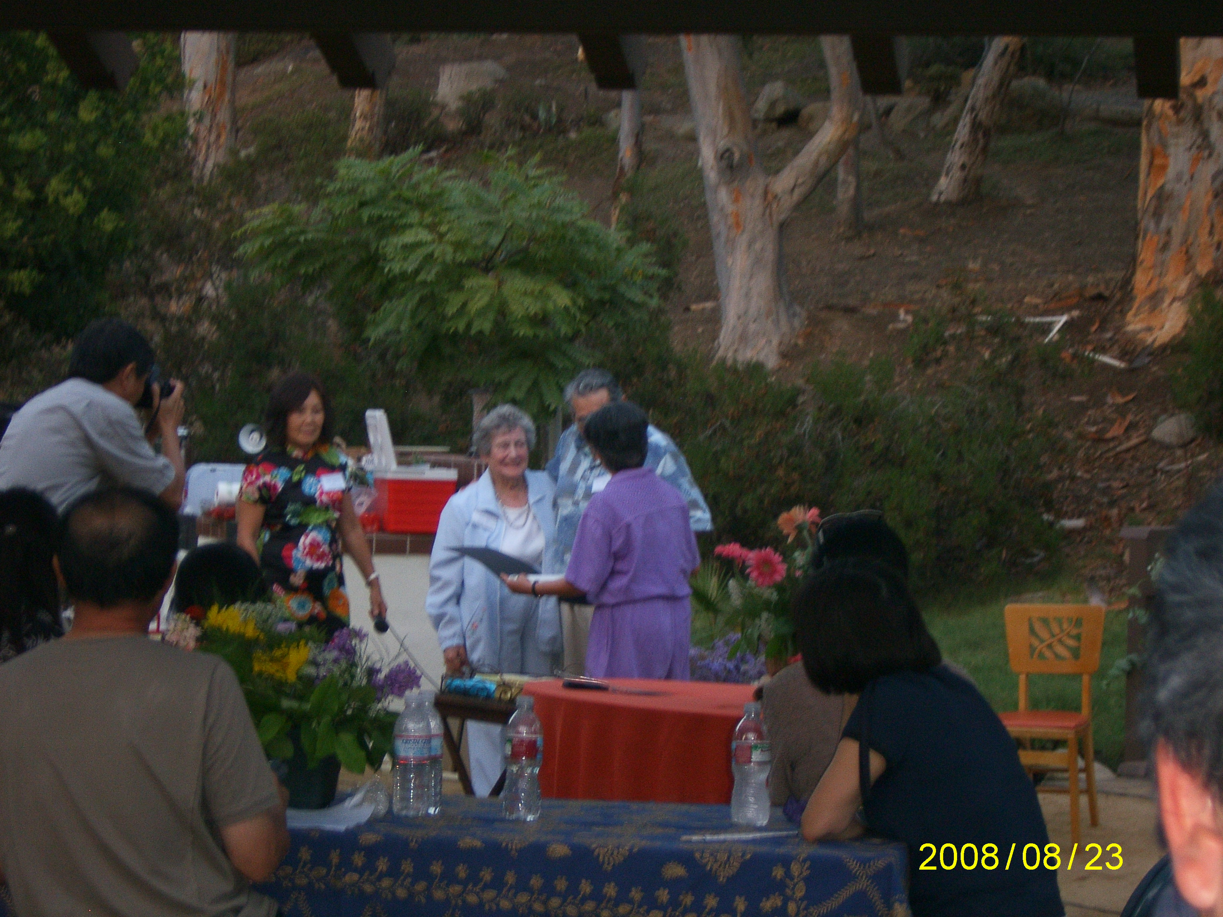
Nancy Lo presented a certificate of appreciation to Dr. Lester Tenney. On the left were w his wife Betty and APHAFIC event committee member Wendy Shih.

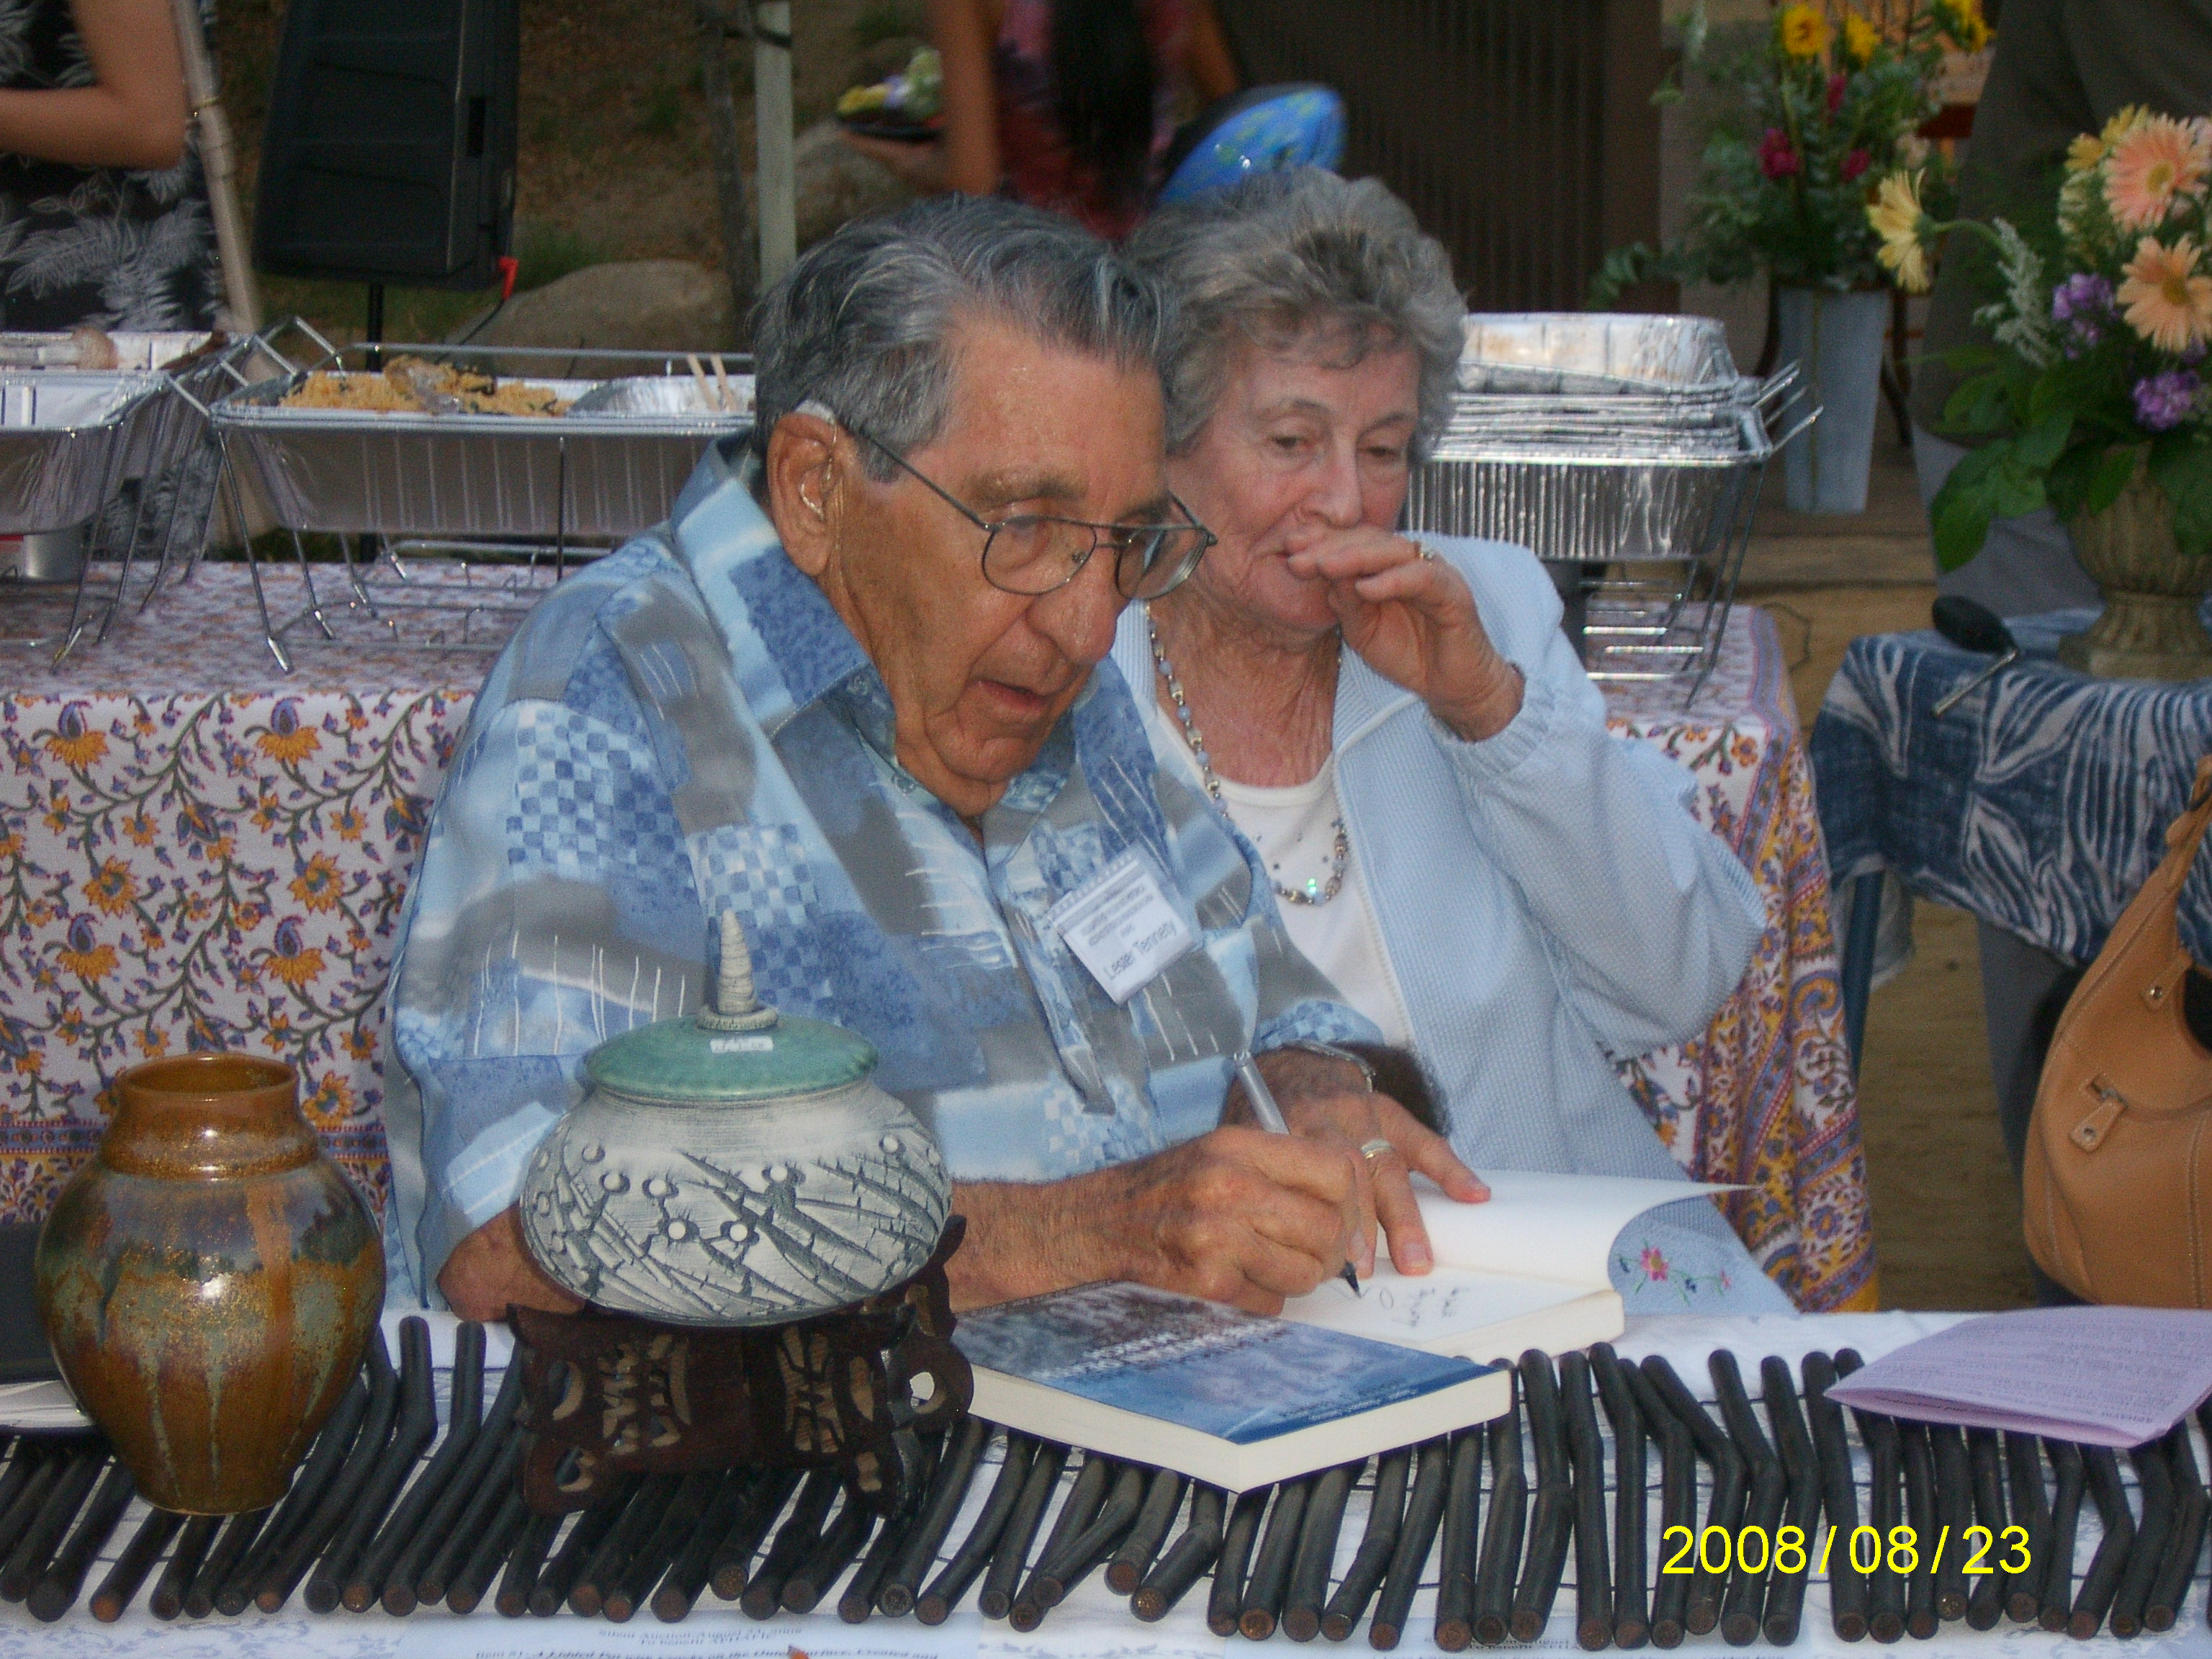
Dr. Lester Tenney signed one of his books with Betty, his wife, on the side.

Lester I. Tenney Ph.D. is a survivor of the infamous Bataan Death March and three and a half years in forced labor working for Mitsui Coal Mines, extracting coal from their mine in Japan. He received his doctor’s degree in Finance from the University of Southern California and was a professor at San Diego State University and retired as Professor Emeritus from Arizona State University. Dr. Tenney is the author of several books dealing with retirement and financial issues. He is also the author of "My Hitch in Hell: The Bataan Death March" an uncompromising story of his experiences in the Philippines and Japan. He also acts as "Expert Witness" in many court cases dealing with insurance or financial matters. Tenney is the first POW to file an individual lawsuit against the Japanese company he worked for while a POW in Japan. Dr. Tenney worked for Mitsui Coal Mine in Japan during the years 1943-1945.

